Appendix A. Questionnaire Used in Experiment 1

Participant ID (Completed by the researcher)
Q1. Please refer to the hand diagram below and select all areas where you felt warmth or heat while using the haptic glove. (Multiple selections allowed.)
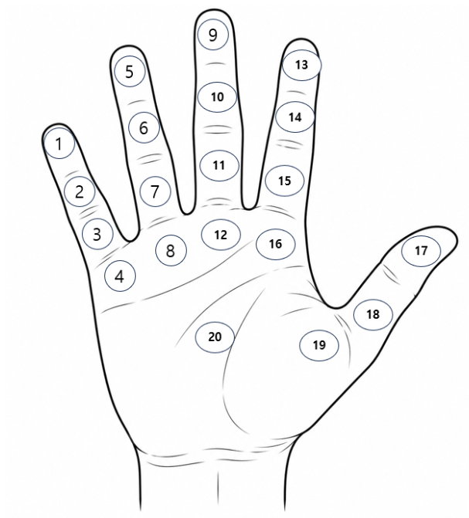
• Tip of the little finger
• Middle phalanx of the little finger
• Proximal phalanx of the little finger
• Base of the little finger (palm side)
• Tip of the ring finger
• Middle phalanx of the ring finger
• Proximal phalanx of the ring finger
• Base of the ring finger (palm side)
• Tip of the middle finger
• Middle phalanx of the middle finger
• Proximal phalanx of the middle finger
• Base of the middle finger (palm side)
• Tip of the index finger
• Middle phalanx of the index finger
• Proximal phalanx of the index finger
• Base of the index finger (palm side)
• Tip of the thumb
• Proximal phalanx of the thumb
• Thenar eminence (base of the thumb)
• Center of the palm
• I did not feel any warmth or heat in any area.

Q2. How strong was the overall thermal sensation (warmth/heat) that you experienced in the selected area(s)?
○ 1 ○ 2 ○ 3 ○ 4 ○ 5
Not felt at all — Felt very strongly

